Chapter 6, Problem 59.

(a) For two inductors in series as in Fig. 6.81(a), show that the current-division principle is

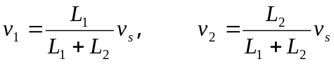

assuming that the initial conditions are zero.

(b) For two inductors in parallel as in Fig. 6.81(b), show that the current-division principle is

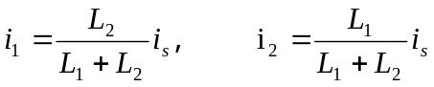

assuming that the initial conditions are zero.

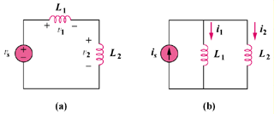

Figure 6.81
For Prob. 6.59.

